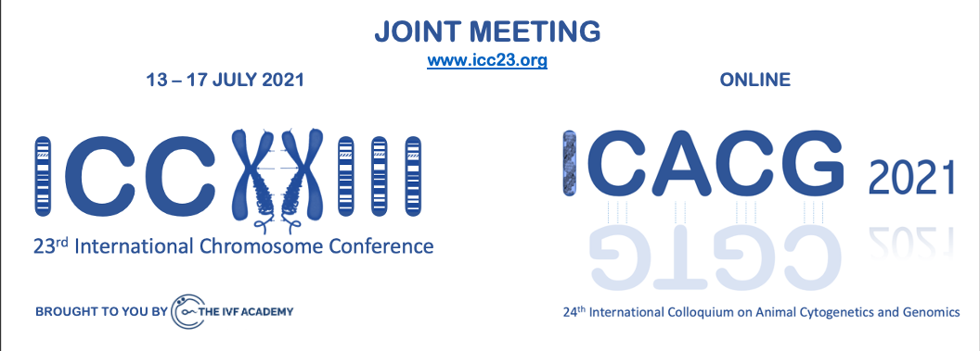

Programme

KEYNOTE SESSION

13th July 2021

- US West coast 4am
- US East coast 7am
- Sao Paulo 9am
- UK (Canterbury) Time 12noon
- France, Spain, Italy, Germany, etc. 1pm
- Dubai, Moscow – 3pm
- Karachi – 4pm
- Bangkok – 8pm
- Canberra – 9pm
- New Zealand 10pm

Opening ceremony, welcome by the Chairs. 15-minute introduction
Darren Griffin, Tariq Ezaz and Janine Deakin

KEYNOTE SPEAKER: Professor Jennifer Marshall-Graves

Chromosomal and epigenetic sex determination

Social Event approximately 1 hour later

Conference Sponsor and Special Issue
24th International Colloquium on Animal Cytogenetics and Genomics (ICACG)

14th July 2021 Canterbury time Canberra Time

Session 1: Emerging technologies (Mohammed Yusuf chair) 10.30am – 12.35pm 7.30pm – 9.35pm
- Mohammed Yusuf. Ultra-structural imaging provides a 3D organization of
46 chromosomes of a human prophase nucleus 10.30am – 10.55am
- Tony Gordon. Technologies for single cell cytogenetic analyses 10.55am – 11.20am
- Misa Hayashida. Higher-Order Structure of Chromosomes Observed by
Electron Diffraction and Electron Tomography 11.20am – 11.45am
- Stanley Botchway. The use of fluorescence lifetime imaging for investigating
chromatin structure and condensation in chromosomes 11.45am – 12.10pm
- Ben Skinner. Image warping for assessing chromatin organisation
in asymmetric nuclei 12.10pm – 12.35pm

Session 2: Animal cytogenetics (Peter Ellis chair) 1.30pm – 3.10pm 10.30pm – 12.10am
- Claudia Rathje. “Clinical” cytogenetics in domestic and endangered species 1.30pm – 1.55pm
- Rafael Kreschmer. Chromosomes in birds and other dinosaurs 1.55pm – 2.20pm
- Kornsorn Srikulnath. Sex, repeats and chromosomes in birds and reptiles 2.20pm – 2.45pm
- Marta Farre-Belmonte. Gross genomic changes within and between species 2.45pm – 3.10pm

Session 3: Accessory Chromosomes (Cesar Martins chair) 3.30pm – 5.10pm 12.30am – 2.10am
- Cesar Martins. B chromosomes in cichlid fish 3.30pm – 3.55pm
- Michael Habig. Christian-Albrechts. Functional characterization of accessory
chromosomes in Fungi 3.55pm – 4.20pm
- Stacey L. Hanlon. B chromosomes in Drosophila 4.20pm – 4.45pm
- Alevtina Ruban. Supernumerary B chromosomes of Aegilops speltoides 4.45pm – 5.10pm
- Patrick Ferree Parasitic B chromosomes 5.10pm – 5.35pm

15th July 2021 Canterbury time Canberra Time

Session 4: Genome evolution (Denis Larkin chair) 10.30am – 1.00pm 7.30pm – 10.00pm
- Denis Larkin. Chromosome evolution in mammals 10.30am – 10.55am
- Anna Torgasheva. A story of the 'spare' chromosome in songbird germ line 10.55am – 11.20am
- Vladimir Trifonov. Patterns of segmental rediploidization in sterlet genome 11.20am – 11.45am
- Helder Maiato. A deer's perspective on mitosis 11.45am – 12.10pm
- Agda Bernegossi. Chromosomal evolution in neotropical deer:
Implications for speciation, taxonomy and conservation 12.10pm – 12.35pm
- Claire Merot. Polymorphic inversions in seaweed fly 12.35pm – 1.00pm

Session 5: Chromosome dynamics in germ cells: 1.30pm – 3.35pm 10.30pm – 12.35am
structure, regulation and evolution (Aurora Ruiz-Herrera chair)
- Paul Waters. Executioner genes and meiosis 1.30pm – 1.55pm
- Takashi Akera. Cell biology of non-Mendelian chromosome segregation
in oocytes 1.55pm – 2.20pm
- Aurora Ruiz-Herrera. Dynamics of 3D genome structure
during spermatogenesis 2.20pm – 2.45pm
- Jesus Page. Meiotic behaviour of sex chromosomes 2.45pm – 3.10pm
- Monica Colaiacovo. Chromosome dynamics in C. elegans meiosis 3.10pm – 3.35pm

Session 6: Complex, Elusive, and Functionally Important 4.00pm – 6.05pm 1.00am – 3.05am
Elements of the Genome (Beth Sullivan chair)
- Lilian Kabeche. RNA:DNA hybrids at pericentromeres (Mammals) 4.00pm – 4.25pm
- Cecile Courret. Satellites and TEs within insect centromeres (Drosophila) 4.25pm – 4.50pm
- Maiko Kitaoka. Centromere driven retention of chromosomes in hybrids 4.50pm – 5.15pm
- Kaustuv Sanyal. Inter-chromosomal interactions give birth to neocentromeres 5.15pm – 5.40pm
- Fangpu Han. Backspliced TE RNAs regulate centromeric chromatin loops 5.40pm – 6.05pm

Social event

Conference sponsored by:

23rd International Chromosome Conference (ICC)

16th July 2021 Canterbury time Canberra Time

Session 7: PLENARY Session (Marta Farre chair) 8.30am - 10am 5.30pm - 7pm
- Jaroslav Doležel. Uncovering 3D topology of plant mitotic chromosomes using
- 3 Different approaches 8.30am – 9.00am 5.30pm – 6.00pm
- Ana Pombo. Specialization of brain cell types encoded in chromatin topologies 9.00am – 9.30am 6.00pm – 6.30pm
- Ting Wu. Doubling down on pairing: from ultra-conservation
to super-resolution imaging 9.30am – 10.00am 6.30pm – 7.00pm
- Robert Neely. Expansion microscopy and its use in chromosome analysis 10.00am - 10.30am 7.00pm – 7.30pm

Session 8: Mammalian Reproduction and Preimplantation Testing 11.00am – 12.40pm 8.00pm – 9.40pm (Darren Griffin, chair)
- Darren Griffin. The human embryonic genome is karyotypically fluid and
dynamic, actively expelling aneuploid cells from the developing foetus 11.00am – 11.25am
- Giuseppe Silvestri. Preimplantation genetics in pigs and cattle 11.25am – 11.50am
- Peter Ellis. Evolutionary conservation of sperm chromosome territories 11.50am – 12.15pm
- Shadi Khalil. Demonstration of teaching PGT with virtual reality 12.15pm – 12.40pm

Session 9: Selected Abstracts and Posters 1.15pm – 2.30pm 10.15pm – 11.30pm
- Talk 1
- Talk 2
- Talk 3
- Poster 1
- Poster 2
- Poster 3

NOTE 7½ HOUR GAP

Session 10: Genome Instability (Helen Tempest, chair) 9.30pm – 11.10pm 6.30am – 8.10am
- Tim Fenton. Genome instability and APOBEC 9.30pm – 9.55pm
- Urszula McClurg. Expression of meiotic proteins in cancer & genome stability 9.55pm – 10.20pm
- Marcus Cooke. Targeted and untargeted analyses of damage to nucleic acids
– contributors to exposomics 10.20pm – 10.45pm
- Helen Tempest. Mechanisms generating aneuploidy in gametes 10.45pm – 11.10pm

Session 11: TBA (Rachel O’Neill chair) 11.30pm – 1.10am 7.30am – 9.10am
- Rachel O’Neill, From telomere to telomere: the transcriptional and
epigenetic landscape of human repeat elements 11.30pm – 11.55pm
- Kim Hyun Hee, Chromosome dynamics inferred from repeatomics
studies in Brassica and Senna species 11.55pm – 12.20am
- Ikuo Miura. Evolutionary history of sex chromosomes in the frog
Glandirana rugosa: Two times turnover and four times recycling 12.20am – 12.45am
- Hardip Patel, TBA 12.45am – 1.10am

17th July 2021 Canterbury time Canberra Time

Session 12: Genome function in the nucleus (Dean Jackson chair) 6.30am – 8.35am 3.30pm - 5.35pm
- Antony Adamson. Recent advances in genome editing 6.30am – 6.55am
- Sankari Najarajan. Applying CRISPR to cancer screening 6.55am – 7.20am
- Pedro Olivares. Techniques to analyse genome structure and function 7.20am – 7.45am
- Angela Pisco. Single cell analysis identifies ageing signatures 7.45am - 8.10am

Session 13: Evolution, structure holo- and mono-centric chromosomes 8.30am – 10.35 am 5.30pm – 7.35pm
(Andreas Houben chair)
- Ines Drinnenberg. Insights into the molecular architecture of CenH3-deficient
holocentromeres in Lepidoptera 8.30am – 8.55am
- Andre Marques. Genome function and evolution in plants
with repeat-based holocentromeres 8.55am – 9.20am
- Miroslav Plohl. The genomic landscape of satellite DNAs and centromeres
in some invertebrate model organisms 9.20am – 9.45am
- Yi-Tzu Kuo. Chionographis - A missing link in the mono- to
holocentromere evolution 9.45am – 10.10am
- Amanda Souza Camara / Veit Schubert. 'Metaphase chromosome
coiling - a conserved feature? 10.10am – 10.35am

Session 14: ERVs (Pat Heslop-Harrison chair) 11.00am – 12.40pm 8.00pm – 9.40pm
- Pierre-Olivier Duroy. Characterization and mutagenesis of Chinese hamster 11.00am – 11.25am
ovary cells endogenous retroviruses to inactivate viral particle release
- Sarbast Mustafa. Identifying ERVs in raw-reads and using these for FISH 11.25am – 11.50am
- Darren J. Wighta. Unbiased optical mapping of telomere-integrated 11.50am – 12.15pm
endogenous human herpesvirus 6"

Social event Venue and date of next meetings Close of meetings

