ICC & ICACG
Conference 2021

Name | Institute | Email | Photo
Darren Griffin | University of Kent | d.k.griffin@kent.ac.uk | 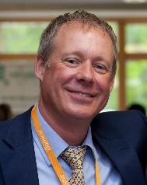
Tariq Ezaz | Uni of Canberra | Tariq.Ezaz@canberra.edu.au | 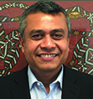
Janine Deakin | Uni of Canberra | Janine.Deakin@canberra.edu.au
Jennifer Marshall-Graves | Australian National University | j.graves@latrobe.edu.au | 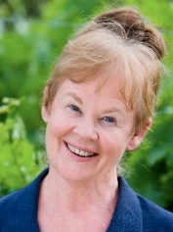
Dr Mohammed Yusuf | Aga Khan University, Karachi | Mohammed.yusuf@aku.edu | 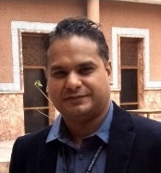
Tony Gordon | Cooper Genomics | Tony.gordon@coopergenomics.com | 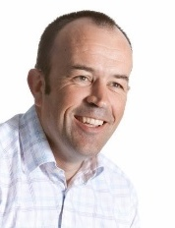
Dr Misa Hayashida | Nanotechnology Research Centre, National Research Council Canada | misa.hayashida@nrc-cnrc.gc.ca
Prof Stanley Botchway | Science and Technology Facilities Council, UK | Stan.botchway@stfc.ac.uk | 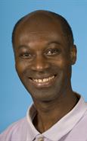
Ben Skinner | University of Essex | b.skinner@essex.ac.uk | 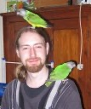
Rafael Kretschmer | Federal University of Rio Grande do Sul, Brazil | rafa.kretschmer@hotmail.com | 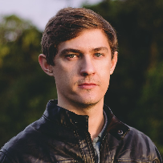
Kornsorn Srikulnath | Kasetsart University, Thailand | Kornsorn.s@ku.ac.th | 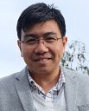
Marta Farre-Belmonte | University of Kent | m.farre-belmonte@kent.ac.uk | 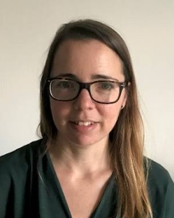
Cesar Martins | Sao Paulo State University, Brazil | Cesar.martins@unesp.br | 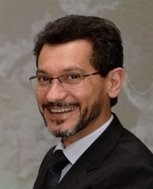
Michael Habig | Christian-Albrechts Universitat Kiel, Germany | mhabig@bot.uni-kiel.de | 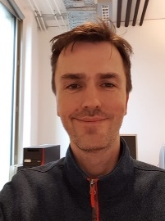
Stacey L. Hanlon | University of Connecticut, USA | Stacey.hanlon@uconn.edu | 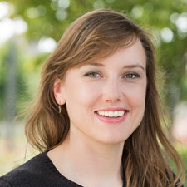
Alevtina Ruban | Leibniz Institute of Plant Genetics and Crop Plant Research Gatersleben, Germany | alevtinarouban@gmail.com | 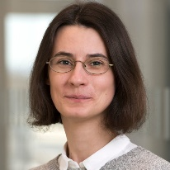
Patrick Ferree | W.M. Keck Science Department, Claremont McKenna College, Pitzer College and Scripps College, Claremont, CA, USA | pferree@kecksci.claremont.edu | 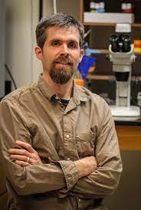
Denis Larkin | Royal Veterinary College | dlarkin@rvc.ac.uk | 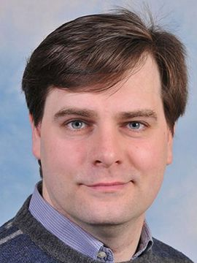
Anna Torgasheva | Institute of Cytology and Genetics, Russian Academy of Sciences, Siberian Department, 630090 Novosibirsk, Russia | torgasheva@bionet.nsc.ru
Vladimir Trifonov | Department of the Diversity and Evolution of Genomes  Laboratory of Comparative Genomics. Institute of Molecular and Cellular Biology  of the Siberian Branch of the Russian Academy of Sciences | vlad@mcb.nsc.ru | 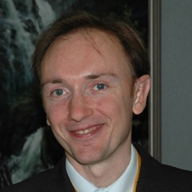
Helder Maiato | Instituto de Investigação e Inovação em Saúde – i3S, Portugal | maiato@i3s.up.pt | 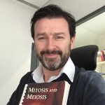
Agda Bernegossi (Duarte's group) | Universidade Estadual Paulista | agm.bernegossi@gmail.com | 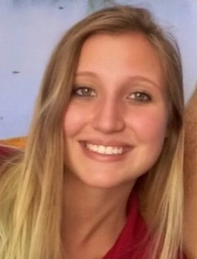
Claire Merot | Universite Laval | Claire.merot@gmail.com | 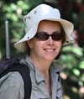
Paul Waters | UNSW, Sydney, Australia | p.waters@unsw.edu.au | 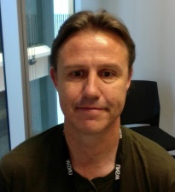
Takashi Akera | NIH, Bethesda, USA | Takashi.akera@nih.gov | 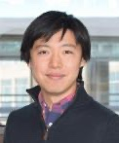
Aurora Ruiz-Herrera | Universitat Autonoma de Barcelona | Aurora.ruizherrera@uab.cat | 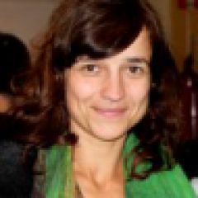
Jesus Page | Universidad Autonoma Madrid, Spain | Jesus.page@uam.es | 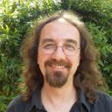
Monica Colaiacovo | Blavatnik Institute of Genetics, Harvard Medical School, USA | mcolaiacovo@genetics.med.harvard.edu | 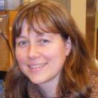
Lilian Kabeche | Yale University | Lilian.kabeche@yale.edu | 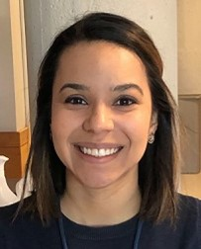
Cecile Courret | University of Rochester | cecile.courret@egce.cnrs-gif.fr
Maiko Kitaoka | UC Berkeley | mkitaoka@berkeley.edu | 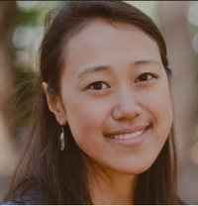
Kaustuv Sanyal | Jawaharlal Nehru Centre for Advanced Scientific Research | sanyal@jncasr.ac.in | 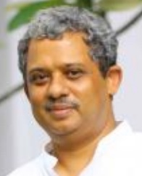
Fangpu Han | State Key Laboratory of Plant Cell and Chromosome Engineering | fphan@genetics.ac.cn | 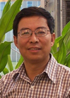
Jaroslav Dolezel | Institute of Experimental Botany of the Czech Academy of Sciences | dolezel@ueb.cas.cz | 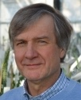
Ana Pombo | Max Delbruck Center for Molecular Medicine, Berlin | Ana.Pombo@mdc-berlin.de | 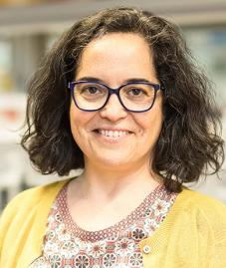
Ting Wu | Wyss Institute, Harvard Medical School | twu@genetics.med.harvard.edu | 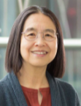
Dr Robert Neely | University of Birmingham | r.k.neely@bham.ac.uk | 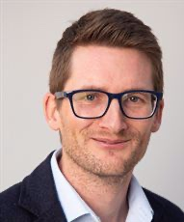
Darren Griffin | University of Kent | d.k.griffin@kent.ac.uk
Giuseppe Silvestri | University of Kent | g.silvestri@kent.ac.uk | 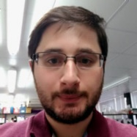
Peter Ellis | University of Kent | p.j.i.ellis@kent.ac.uk | 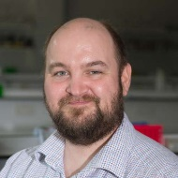
Shadi Khalil | University of Kent, the IVF company | Shadi.khalil10@googlemail.com | 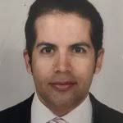
Tim Fenton | University of Kent | t.fenton@kent.ac.uk | 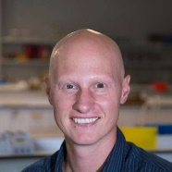
Urszula McClurg | University of Liverpool | Urszula.mcclurg@liverpool.ac.uk | 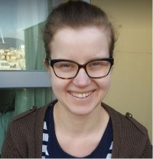
Marcus Cooke | University of South Florida | cookem@usf.edu | 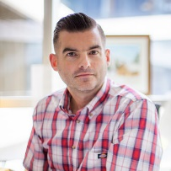
Helen Tempest | Herbert Wertheim College of Medicine, Florida International University | htempest@fiu.edu | 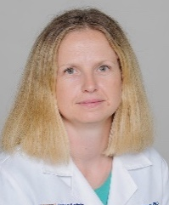
Rachel O'Neill | University of Connecticut | Rachel.oneill@uconn.edu | 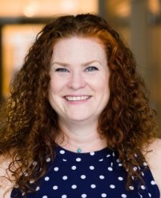
Kim Hyun Hee | Sahmyook University | kimhh@syu.ac.kr
Ikuo Miura | Hiroshima University, Japan | imiura@hiroshima-u.ac.jp | 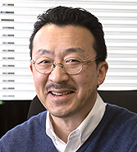
Hardip Patel | Australian National University | Hardip.patel@anu.edu.au | 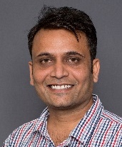
Antony Adamson | University of Manchester | antony.adamson@manchester.ac.uk | 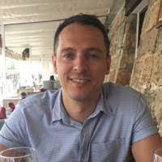
Sankari Nagarajan | University of Manchester | Sankari.nagarajan@manchester.ac.uk | 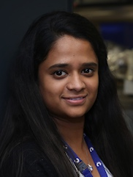
Pedro Olivares Chauvet | Max Delbruck Center, Berlin | pedro.olivares@mdc-berlin.de | 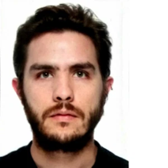
Angela Pisco | Chan Zuckerberg Biohub, San Francisco | angela.pisco@czbiohub.org | 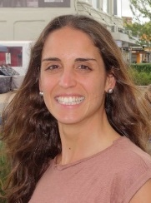
Ines Drinnenberg | Institut Curie, Paris, France | Ines.drinnenberg@curie.fr | 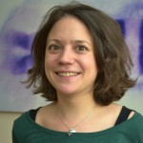
Andre Marques | Max Planck Institute for Plant Breeding Research, Cologne, Germany | amarques@mpipz.mpg.de | 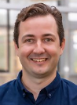
Miroslav Plohl | Ruder Boskovic Institute, Zagreb, Croatia | plohl@irb.hr | 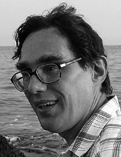
Yi-Tzu Kuo | IPK Leibniz Institut | kuo@ipk-gatersleben.de | 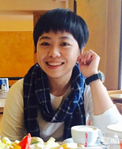
Amanda Souza Camara  Veit Schubert | IPK Leibniz-Institut  IPK Leibniz-Institut | camara@ipk-gatersleben.de  schuberv@ipk-gatersleben.de | 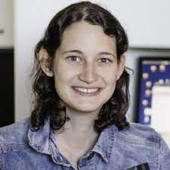  Shared talk
Sarbast Mustafa |  | sarbast.ihsan@uod.ac | 